**For Immediate Release**

**AIR Music Tech Announces Soft Clipper: The Ultimate Clipping Solution**

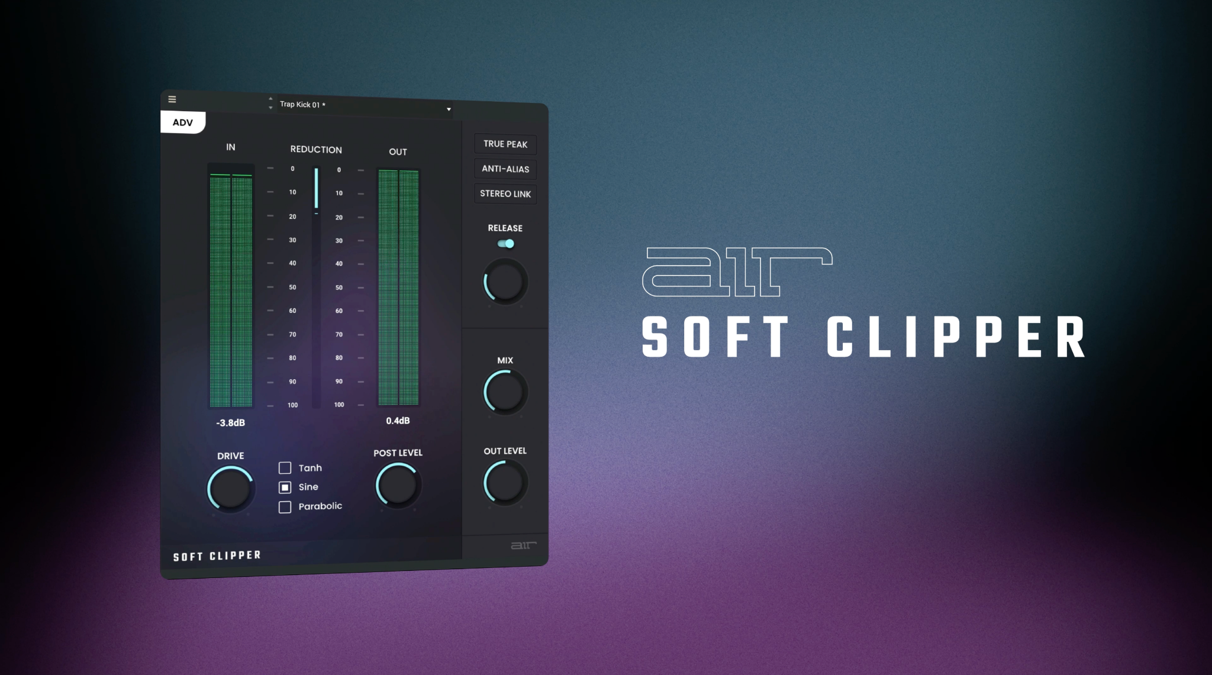

**Cumberland, RI, USA, June 18, 2024 — AIR Music Tech, a pioneer in audio software development, introduces the AIR Soft Clipper plugin. Designed for genres like R&B, Rap, Drum and Bass, and edgy Pop, the AIR Soft Clipper improves on traditional clipping technology to provide producers with enhanced energy and clarity in their mixes.**

**A New Standard in Clipping Technology**The [AIR Soft Clipper](https://www.youtube.com/watch?v=BgjJqHU3OeE) offers a unique combination of usability and advanced functionality, positioning it as a crucial tool in any producer’s arsenal. It delivers the loud, clean, release-ready sound that distinguishes professional tracks. The Quick View mode provides instant access to primary controls, making it easy for users of all levels to achieve professional results quickly. Key features include:

* **Drive:** Explore a wide range of saturation effects, from subtle enhancements to intense layers, shaping the tonal character of your tracks.
* **Post Level:** Ensure consistent output levels while maintaining the integrity and edge of the mix.
* **Meter:** Provides real-time feedback for precise adjustments, eliminating guesswork.

**Advanced Features for In-Depth Customization**For those seeking more control, the Advanced View mode offers a comprehensive set of tools to fine-tune the sound:

* **Shape:** Customize the clipping curve to create either smooth transitions or hard-hitting effects.
* **True Peak & Anti-Alias:** Advanced options to minimize distortions and artifacts, ensuring a clean, crisp output.
* **Stereo Link:** Maintains balance between left and right channels, preventing imbalances and enhancing stereo cohesion.

**Precision Control for the Perfect Mix**In addition to its extensive feature set, the AIR Soft Clipper includes detailed parameters for more control when mixing and mastering:

* **Release Time:** Adjust the duration of the clipping effect to suit the track’s needs, from quick fades to extended presence.
* **Mix:** Blend the original and processed signals seamlessly to achieve the desired sonic texture.
* **Out Level:** Fine-tune the output level to ensure the final mix sits perfectly within the overall production

**Formats**

* macOS: AU, VST, VST3, AAX
* Windows: VST, VST3, AAX
* MPC OS: 2.14.2

**Pricing & Demo**The AIR Soft Clipper is available for $29.99 with an introductory promo price of $19.99 until July 2, 2024. A 10-day demo can be downloaded from [AIR Music Tech](https://www.airmusictech.com/).

**About AIR Music Tech**One of the earliest pioneers in virtual instrument technology, AIR is dedicated to creating the world’s most advanced and easy-to-use virtual instruments. Our team is responsible for the core of much of the effects offerings in Avid’s Pro Tools ® software.

###

Hunter Williams

+1 (518) 534-9170

hunter@hummingbirdmedia.com